Carolena Realmuto

Lab 9- Normalization 3

CMPT 308

1.functional dependencies:

PID 🡪 first_name, last_name, address, phone

HCID🡪yearscoach

ACID🡪yearscoach

PLID🡪TID

LID🡪AgeGroup

TID🡪TeamName, LID, HCID

[HCID, LID]🡪TID

2.E/R diagram: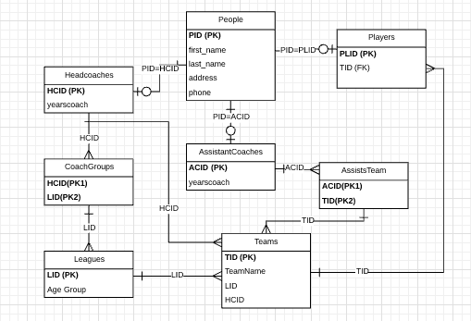

3. This database is in *at least* 3NF because it is in 1NF and 2NF and every non-prime attribute in each table describes the key, the whole key, and nothing but the key (so help me Codd!). This database is may also be in BCNF because when looking at the functional dependencies, their form X🡪Y is a trivial functional dependency.